Blade Bastards world concepts
1. Space frontier

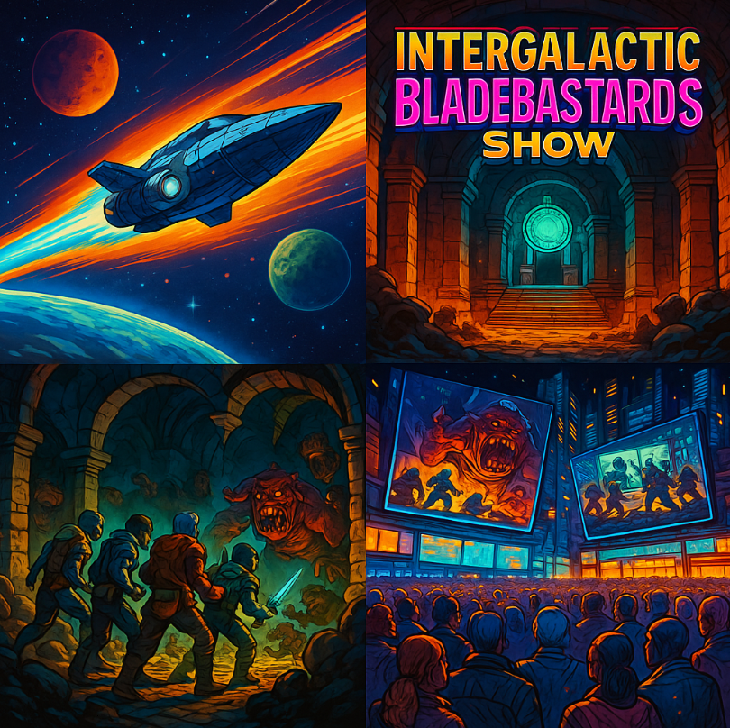

It is the year 5079. Following the introduction of a space travel the universe is now the new frontier booming with various worlds, races and possibilities, too vast and volatile to be controlled by one single organization. This lawless universe is filled with danger but also opportunities for those willing to risk their lives to gain fame and fortune. By the popular demand The Interstellar Network is running an "Intergalactic Bladebastards Show" built on top of a mysterious temple recently discovered on a remote planet. Every week billions are watching on their screens as the few brave warriors and fortune seekers from different planets are teaming up to descend into the dungeons filled with very real monsters and traps. Their goal is to fight their way through the dungeons and uncover the secrets of the Final Chamber, that nobody has ever reached before. The chances of survival are slim but the rewards and fame are well worth the risk.

2. Authoritarian Universe
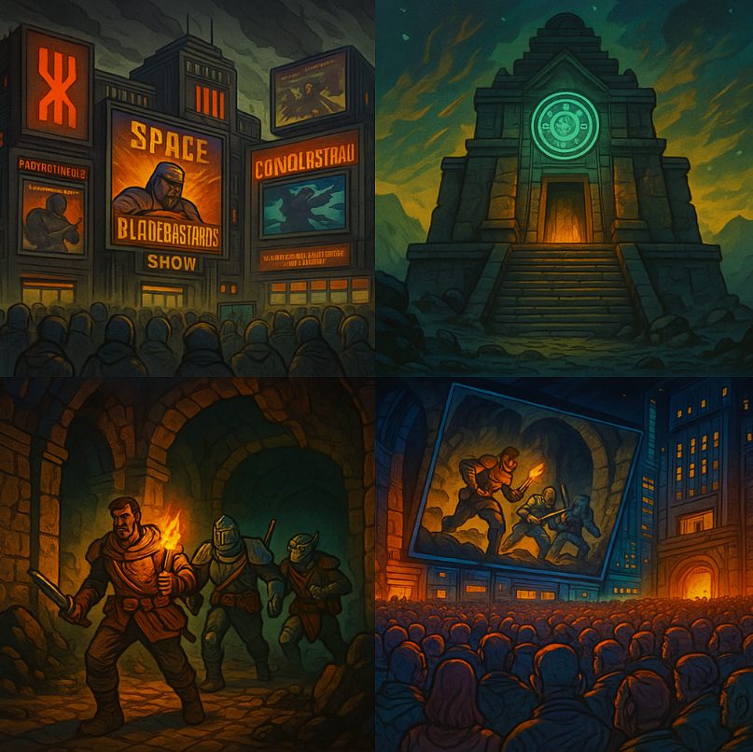

it is the year 5079. After a bloody intergalactic war the known universe is a now a pacified mixture of various pauperized species and impoverished worlds controlled by the authoritarian Space Conglomerate. The Interstellar Television is its widespread mean of influence and propaganda, developed to divert the attention of the starving masses from its hardship and lack of prospects. The most popular program is the "Intergalactic Bladebastards Show" built on top of an ancient evil temple recently discovered on a remote planet Abbadon. Every week billions are watching on their screens as the few brave warriors from different planets are teaming up and descend into the dungeons filled with very real monsters and traps. Their goal is to fight, survive and to reach the hidden temple chamber and uncover all its secrets. The chances of survival are slim but the rewards and fame are well worth the risk.
Temple’s Lore:
The venue of the insanely popular Intergalactic Dungeon Slasher Show: a secret temple on the planet Mawrth has been discovered a while ago. Its origins are unclear but it is said that it was built hundreds of years ago by the first space colonists who were a religious bunch seeking isolation from the modern world. To their surprise they discovered an alien artifact in one of the mines and sought to harness its immense power. However they quickly succumbed to its dark influence because the artifact corrupted every life form it touched and twisted it into something alien and hostile. It didn’t take long before the colonists started to worship it as a deity and built a temple around it. With time they entirely lost their humanity and turned into mindless monsters roaming the depths of the temple. Those terrifying creatures are now jealously guarding the artifact, attacking everything and everyone who tries to get near it.
Master of the Ceremony/Host Lore:
The planet was rediscovered a couple of years ago by a notorious scavenger and fortune seeker - Lazy Eyed Hank - who pawned his family residence: an asteroid to get his hands on the coordinates of the mysterious planet Mawrth who – as legend has it – was supposed to be full of treasures. He landed his ship there and send his hired guns to ransack the temple. Instead of gold most of them found gruesome death by the monsters who tore them apart on sight. The rest wanted nothing more than to escape this god forsaken planet. But where simple minded folk saw obstacles - Lazy Eyed Hank immediately saw the biggest opportunity of his life. He was broke anyway and all he had now was this barren rock with a temple full of fucking monsters. So, he decided to turn this setback into an opportunity and create the biggest show in the galaxy. He would then sign the lucrative contract with the interstellar television and assume the role of the Master of Ceremony, hosting the show every Sunday at 8 PM Interstellar Standard Time. He never learned about the artifact and the source of monster infestation. He suspected that there might be something at the bottom of the temple but he didn’t really care as long as the show was a success. He even decided to make it part of the show and call it The Ultimate Chamber. For those brave (or stupid) the deepest dungeons of the temple could be hiding a treasure beyond imagination but off course Lazy Eyed Hank hoped that the crazy warriors will only find death there, so his show could continue indefinitely.
Temple’s Lore:
Intergalactic Dungeon Slasher Show is nowadays one of the most popular tv shows in the galaxy. Its venue is an old, mysterious temple on a remote planet Mawrth – a barren world that nobody would ever visit willingly. It was a home to a group of religious settlers who sought to mine rare minerals. All went well until one day they stumbled upon an ancient interdimensional gate buried in the mine. Believing it could be a sacred gateway to heaven, they made every effort to open it and even built their own temple around it. When they finally powered it up, some volunteers step through those gates, hoping to get to heaven. They came back twisted and changed, bringing all sorts of monsters with them. The nightmarish creatures from other dimension tore the remaining colonists apart and everything went quiet in the temple for the next hundreds of years.
Master of the Ceremony/Host Lore:
Hundreds of years later the remote location of the planet became known to a notorious prospector and treasure hunter – one Lazy Eyed Hank who even pawned his home asteroid to get his hands on the coordinates. Rumor had it the forgotten planet Mawrth was full of riches just ripe for the taking. When he arrived on the planet with his crew, they were immediately attacked by twisted monsters. No riches – just bloodthirsty creatures wanting nothing more than to tear you apart. It was an unfortunate turn of events to be sure but Lazy Eyed Hank was not that easily discouraged by the circumstances. Because he already invested everything he owned in this planet and a goddamn temple full of monsters, he decided to make profit of it anyway he could. He decided to turn the place into a televised spectacle with added traps, blades and flame throwers where warriors from different planets would fight the monsters for fame and glory. This deranged idea was an instant success. Lazy Eyed Hank signed a contract with the interstellar television and became the Master of the Ceremony, hosting his own show every Sunday at 8 PM Interstellar Standard Time. He never figured out the truth about the interdimensional gateway in the lowest part of the temple, but he didn’t really care as long as the show had a steady influx of monsters to kill and the space warrior contestants to do the killing. He even decided to make it part of the show and call the level that nobody ever reached The Ultimate Chamber. For those brave (or stupid) enough the deepest dungeons of the temple could be hiding a treasure beyond imagination but off course Lazy Eyed Hank hoped that whoever riches the final room will only find death there and his show will continue indefinitely.

