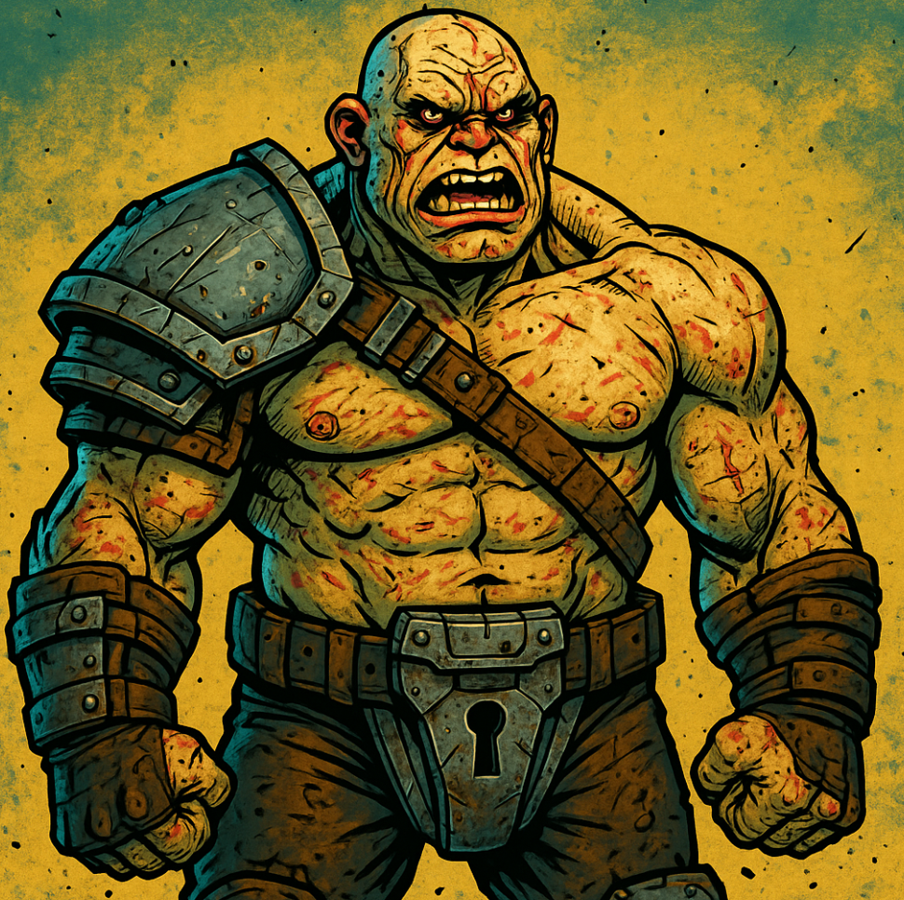
Killer Sidekick (Rusty Max)
Enneagram Type:
2 (Sidekick)
Self-talk:
Bros before foes. And hoes.
Traits:
- Sacrificing
- Tough
- Praising
- Giving
- Loyal
- Possessive
- Team-oriented
Description:
A warrior from a desolate desert world that barely survived a nuclear apocalypse. Hardened by countless wounds, he gained his battle proficiency by slaying mutants and degenerates alongside his team. His brothers and sisters in arms are the most important thing to him, and their safety always comes first. Not the sharpest tool in the shed, but fiercely loyal. He would gladly fall on a live grenade for his friends—but unfortunately, they ran out of grenades in the last war. What can you do.
References:
Drax, Hodor, The Hound

Long-Term Goal:
To belong

Short-Term Goal:
Help his companions defeat the AI

Resources:
Post-apocalyptic survivalist; knowledge of modern weapons; simple-minded; Enneagram Type 2 traits

Chatters

Hero is wounded and waits for help:
- I can take it.
- I’ve been through worse.
- Don’t mind me.
- I’ll survive.
- Patch yourself up first.
- I survived an atomic blast—I can survive this.

Hero enjoys the fight:
- Get them! I got your back!
- There’s nothing like a good brawl with friends!
- Onwards! For the team!
- We can win this—together!
- I’m definitely into group sports like this.
- I’ll never let you down, comrades!

Hero is bored:
- You need more than one oar to row a boat... I think.
- There’s strength in numbers—at least that’s what my math teacher said.
- Soooo… what’s next?
- Are we waiting for something? A nuclear holocaust, perhaps?
- If I stand still long enough, I become invisible.
- Let’s do something! This is boring.

Hero is gathering gold:
- Don’t worry, I share.
- Our future looks brighter already—and I don’t mean the nuclear explosions.
- Soon we can retire and build a house together!
- You know I’d give it all up if you asked me to.
- What’s mine is yours.
- Sharing is caring.

Hero is surprised (WTF moment):
- We need to consult on this, guys.
- That wasn’t part of the plan, was it?
- Maybe we should talk this through?
- So... what do you think this is?
- Holy mother of Atom… any thoughts?
- You haven’t seen anything like this either, have you?

Hero is calling to action:
- That’s our cue.
- Follow the leader!
- Our destiny awaits!
- Time to resume our quest, friends.
- Let’s get on with it, comrades.
- Best deal with it head-on, team!

